

Faculty of Arts, Humanities and Social Sciences
Cambridge School of the Creative Industries

MOD008619
Technical Development for Games

Element 010
Development Report

SID: 2307552

Academic Year 2025/26

Declarations
External Sources
My external sources are cited properly and listed in the References section, using CTR Harvard Referencing.
AI Tools
I have used no AI tools in the creation of the report or the artefact.

Contents
Declarations 2
Contents 3
Table of Figures 3
Introduction – 229w 5
Context 6
CFD: The Why 6
Saving Time 6
Saving Costs 6
Obtaining Optimal Processes 6
Addition of further variables 7
Use Cases of CFD 7
HVAC 7
Water and wastewater treatment 7
Vehicle Aerodynamics 8
Navier-Stokes Equations 8
CFD applications to general Software Engineering 8
Prior Approaches 10
Eulerian Approach 10
Lagrangian Approach 10
Eulerian-Lagrange Approach 10
Recommendations 11
Implementation 11
Particle settings 11
Particle spawner 11
Pressure 11
Viscosity 11
Surface tension 11
Conclusion and Reflection 12
References 13
References 14

Table of Figures
Figure 1 The three reasons why water technologists use advanced CFD (Audenaert, 2023) 6
Figure 2 Visualisation of water flows after improving the design using CFD technology (AM Team, 2018) 7
Figure 3 Visualisation of pressure distribution and velocity field around the F1 car (Abdelkarim, 2025) 8
Figure 4 Navier-Stokes Equations (NASA, 2021) 9

Be sure to ‘update’ the tables of contents and figures before submission, after you have finalised your headings and figures. If you have no figures, you may remove the table of figures and its heading.

Introduction – 229w
Computational Fluid Dynamics (CFD) is a complex system used to model the behaviour of liquids and gases, with applications across industries including aerospace, automotive, energy, water-treatment and HVAC. CFD is used to model fluid behaviour, helping to minimise costs while improving safety and performance. Two common approaches used for particle modelling are the Lagrangian and Eulerian methods.
The Lagrangian method simulates each particle individually, allowing detailed tracking of particle position and velocity, which can provide highly resolved information on flow behaviour (Schroder & Schanz, 2022). In contrast, the Eulerian method treats the fluid and particle phases as continuous media, solving governing equations for each phase simultaneously. This approach is particularly effective for dense gas–solid flows where interphase interactions play a significant role, and it offers improved computational efficiency for large systems (Wang, et al., 2017).
A key consideration when creating a CFD model is the computational cost associated with simulating many particles and interactions. This report will investigate how CFD models have previously been implemented, with the aim of understanding practical applications of CFD, identifying methods to improve computational efficiency and enable the modelling of larger, more complex systems. A model of 2D fluid dynamics has been created alongside this report and is provided, this uses a Euler-Lagrangian method, with each particle being simulated individually while also using a grid-based structure to more efficiently process the required interactions.

Context – 876w

CFD: The Why
When considering the practical uses for CFD, there are three main reasons: to save time, to save costs, and to obtain more optimal processes. Fig1 (below) shows a matrix given by Audenaert which outlines these.

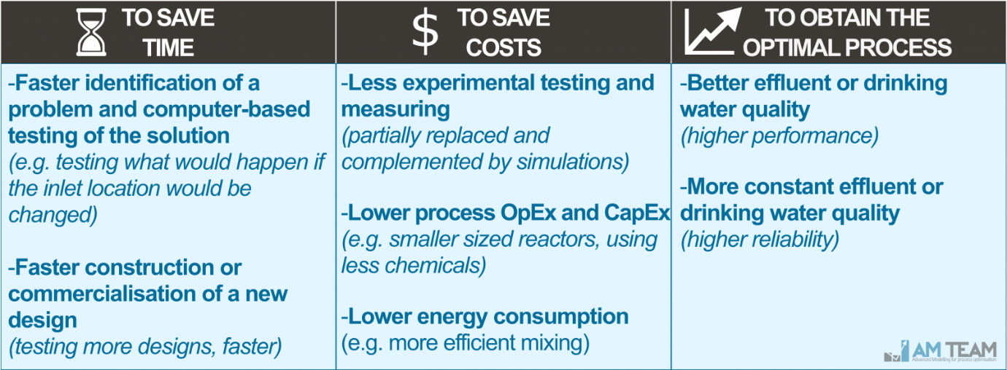
Figure 1 The three reasons why water technologists use advanced CFD (Audenaert, 2023)

Saving Time
By using a computer model for fluid flows, it is more time efficient to test different design scenarios in the easily configurable environment of a computer-based model when compared to building real-world systems, additionally when constructing or commercialising a new design it will be faster and more efficient.

Saving Costs
By not having to spend time and money on the manufacturing and implementation of a design before it has been validated it can save considerable amounts of money to the engineering process and can reduce experimental testing down to fewer real-world scenarios.
Testing of different design structures can be used to get the most efficient placements of the components of the design, for example testing placement of pumps, and mixers in a larger water system to determine where, and how many are required to achieve the desired outcome, this could allow reducing the total amount of pumps required, or determining at which flow rates a given pump can be switched off to reduce Capital Expenditure and Operational Expenditure.

Obtaining Optimal Processes
The last core reason given by Audenaert is process optimisation, he shows that the outcome of these models ‘In two weeks time, the optimal design was found and implemented at the plant. The plant now operates optimally with superior performance. Model accuracy was also proven using onsite data.’ (Audenaert, 2023).

Flexibility
In addition to the above, when simulating fluid behaviours, we can also add in extra factors and variable that extend the functionality of the model. This could include modelling how biological life in the water affects the behaviours of the larger system. In general, greater flexibility gives opportunity to text a large variety of use cases and is one of the key reasons why CFD is used across so many industries.

Use Cases of CFD

HVAC
CFD proves a valuable tool that makes many engineering processes more efficient, we see evidence of this in HVAC as ‘CFD can be a powerful tool for designing and optimizing fluid mechanics in a variety of use case applications.’ (Kenah, 2023), Kenah further explains that businesses ‘can identify potential problems, optimize system performance, and design more efficient and effective building systems.’ This provides value in reducing costs to operate and maintain building systems, and by reducing the energy cost, this reduces the impact to both the business and environment.

Water and wastewater treatment
In water modelling CFD is used to model how to efficiently move and process water, this is commonly used in water and wastewater treatment processes (Audenaert, 2023), Audenaert demonstrates how in water storage containers we can model the flows of water from inlet to outlet which can illustrate how the water mixes – this provides information on how long a given water molecule will remain in the container. By modelling this it allows changing of a system design to see the outcome of different inlet-outlet locations and how it affects behaviour in a cheaper way than manufacturing and measuring real-world implementations.
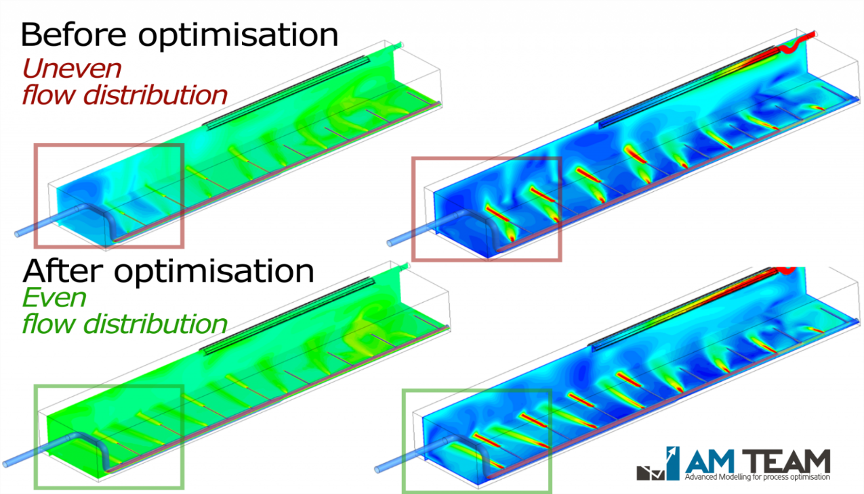
Figure 2 Visualisation of water flows after improving the design using CFD technology (AM Team, 2018)

Vehicle Aerodynamics
In a study on the applications of Aerospace Aerodynamics using CFD for optimisation of Formula 1 car performance (Abdelkarim, 2025), Karim explores the use of CFD to determine best wing setups with varying downforce to optimise the balance between downforce and drag. It was determined that using high downforce setups at race circuits with higher cornering demand is more efficient, compared to using low drag setups at tracks with more straight-line sections. Karim used the SimScale cloud based CFD platform to replicate wind-tunnel conditions to test the turbulent flow properties when applied across a simplified mesh of a formula 1 car.
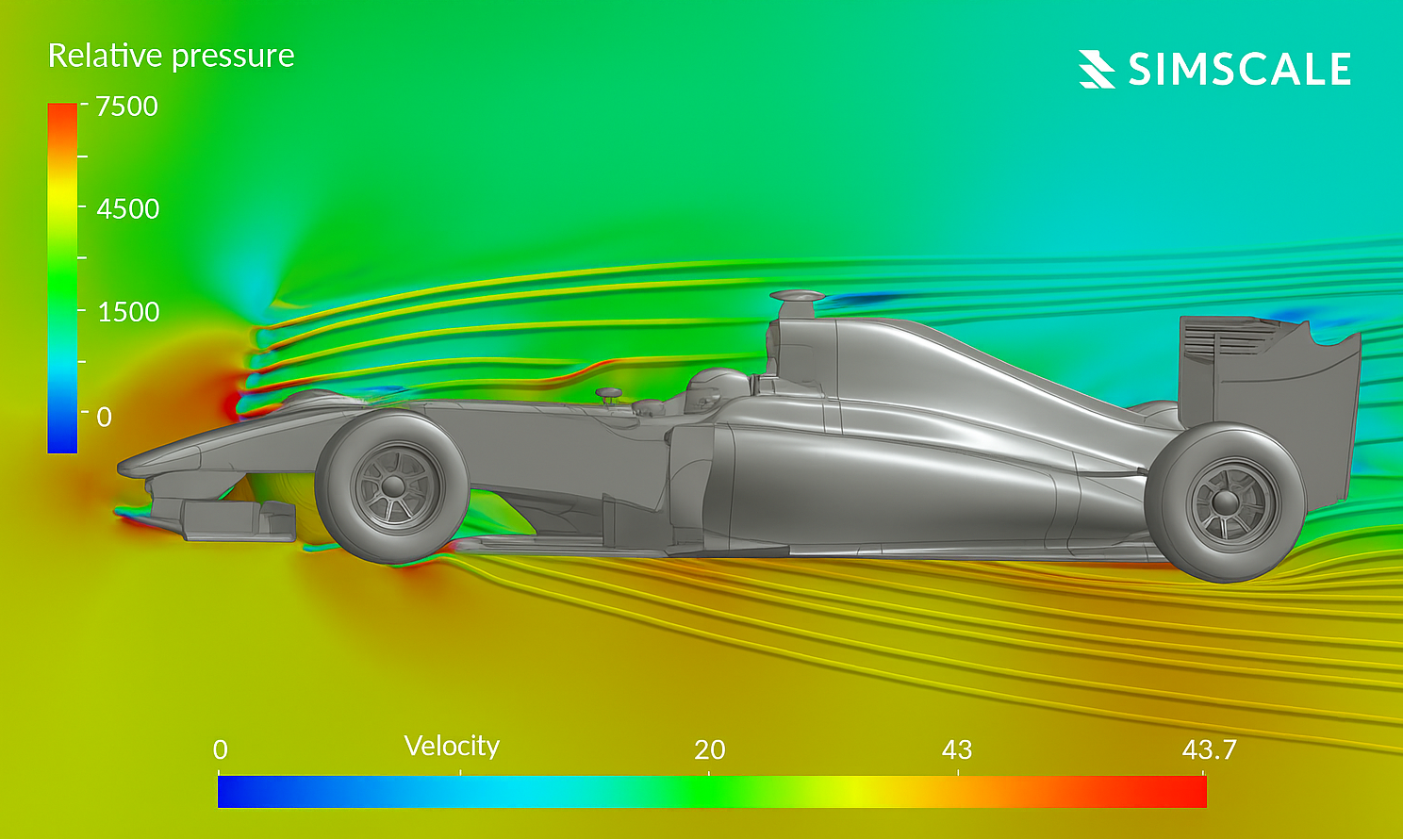
Figure 3 Visualisation of pressure distribution and velocity field around the F1 car (Abdelkarim, 2025)

Navier-Stokes Equations
The Navier-Stokes equations are a set of coupled differential equations that describe the relationship between pressure, temperature, and density of a moving fluid (NASA, 2021), these equations play an important role in any CFD model as they model the behaviour of the fluids used in a built system. NASA outlines the complexity of these equations, describing them as too difficult to solve analytically. By using CFD to solve these equations in real-time we can approximate the behaviour for effective modelling of fluids in real-world applications.
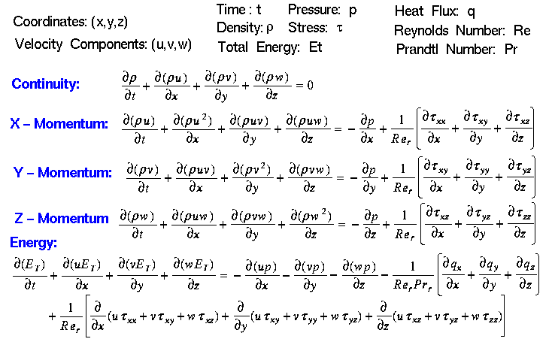
Figure 4 Navier-Stokes Equations (NASA, 2021)

CFD applications to general Software Engineering
CFD modelling touches on a few key concepts that can be applied to other areas of software engineering. As CFD is very computationally heavy, we can learn from the necessarily time efficient nature of CFD projects to ensure we build systems that have lower computational overhead. Data driven decision philosophy is also an important concept in CFD, as the systems are designed to measure the simulated outcome of a given setup, we can use this design – test – improve cycle to apply to projects in any software program we create to ensure a proper validation process with a test-driven production.

Prior Approaches
Recommended word count: 700 words, including any subsections you decide to add.
Use this major section to examine one or more approaches that others have used to address the challenge you are interested in, or similar ones. Ideally you would find multiple approaches so that you can compare and contrast them, but you can concentrate on one strategy if you can find enough to say about it.
Your sources should be knowledgeable and reliable ones where possible, such as developer logs, but tutorials can be useful (especially if you can compare them or have time to try them to test how well they work). Player speculation as to how a feature is implemented can be useful, but should not be your main resource.
If you are struggling to find good enough sources as described above, you may need to adjust the direction of your investigation slightly, finding new aims that can be more easily sourced.
Try to understand (and highlight to the reader as appropriate) how these approaches work, and what makes them suitable for use in the context you’ve established. One aim of this section is for you to develop your understanding of these techniques, and demonstrate it to a deep level.
As you explore one or more approaches, you may comment on how effective they might be for you, but note that there are words available for that in the Recommendations section.
You may divide the approach into subsections (with ‘heading 2’), such as your methods for key areas of the project, or for particular aspects of development. Take care of the total recommended words for the section overall.
You must reference all your sources in CTR Harvard Style.
There are two unique approaches when creating a CFD model to simulate fluid behaviour. The Eulerian model looks at specific locations that the fluid moves through to track the changes, this could be visualised as sitting on the bank of a river and watching the water pass the fixed location, whereas the Lagrangian model follows and individual parcel of fluid as it moves through space and time, this can be visualised as sitting in a boat and drifting down a river. This report will investigate how each approach has a different solution for each of the problems posed by CFD.

Eulerian Approach
As mentioned previously, the Eulerian approach focuses on observing how fluid properties change at fixed locations in space, rather than tracking individual particles as they move. In this framework, variables such as velocity, pressure, density and temperature are defined as continuous fields within a grid of control volumes. The Navier–Stokes equations are then solved at each grid cell over time. Because the equations are applied to the mesh rather than to individual particles, the overall computational cost depends primarily on mesh resolution.
In multiphase modelling, this approach is often implemented using a Euler–Euler formulation. In this model both gas and solid phases are treated as interpenetrating continua rather than as separate discrete particles. Instead of tracking each particle individually, the dispersed phase is represented using averaged properties such as volume fraction and momentum exchange terms. Wang et al. (2017) explain that this method is particularly suitable for dense gas–solid flows where the number of particles would make individual tracking computationally impractical. By representing the solid phase statistically, the system can model large-scale interactions without resolving every collision.
One of the main advantages highlighted by Wang et al. (2017) is scalability. Because the number of equations solved is determined by the number of grid cells rather than the number of particles, Eulerian models are more efficient for industrial-scale systems such as pneumatic conveying. This makes the approach more appropriate for modelling large domains where capturing overall flow behaviour is more important than resolving individual particle trajectories.

Lagrangian Approach
The Lagrangian method in CFD analyses fluid motion by tracking individual particles as the move through space and time. Instead of focusing on fixed locations, it focuses on following each particle and computes how its velocity, position, and density change along its trajectory. This method is particularly useful for modelling particle transport, sprays, and multiphase flows. It provides detailed path information but can become computationally intensive for large fluid systems.
In multiphase CFD modelling, the Lagrangian method is commonly used to represent dispersed phases such as droplets, bubbles, or solid particles within a continuous fluid. The surrounding fluid is often still solved using an Eulerian grid, while individual particles are tracked separately using Newton’s laws of motion. Schroder and Schanz (2022) explain that this approach allows highly detailed measurement of particle trajectories, making it particularly useful when understanding transport mechanisms, collision behaviour, or particle dispersion is important.
The main advantage of the Lagrangian approach is the level of detail it provides. Because each particle is resolved individually, the model can capture micro-scale interactions and precise path information. This makes it suitable for simulations involving sprays, combustion systems, sediment transport, or particle tracking studies where trajectory accuracy is required.
However, the computational cost increases significantly as the number of particles increases. Unlike the Eulerian model, where complexity depends on mesh size, the Lagrangian method scales directly with particle count. In systems with very high particle density, this can make simulations expensive and less practical for large-scale industrial problems. As particle numbers grow, additional calculations are required for forces such as drag, lift, gravity, and potential collisions, which further increases processing time.
For this reason, while the Lagrangian approach provides greater physical detail, it is often more suitable for dilute flows or systems where particle-level behaviour is a priority rather than overall averaged flow behaviour.

Lagrangian-Eulerian Approach
CFD-DEM model
The Lagrangian–Eulerian approach in Computational Fluid Dynamics (CFD) combines both fixed spatial observation and particle tracking methods. The fluid phase is typically solved using the Eulerian framework on a grid, while discrete particles, droplets, or bubbles are tracked individually using the Lagrangian method. This hybrid technique is especially effective for modelling multiphase flows, sprays, and particle-laden systems. It captures detailed particle behaviour while efficiently resolving the surrounding continuous fluid field.

https://web.archive.org/web/20140725014123/https://docs.nvidia.com/cuda/samples/5_Simulations/particles/doc/particles.pdf

Recommendations
Recommended word count: 700 words, including any subsections you decide to add.
Use this major section to set out the your findings, in the form of recommendations you could use or give your reader. Remember the original simulated goal of a senior coworker asking you to find out more about the technique: this is your opportunity to share what you’ve found.
Describe the technique you ought to use, showing its strengths and recognising any remaining issues (although there are additional words available for this in the next section). You should consider challenges that might still need to be solved, and how you could protect against them in a future project. You could also comment on what related things might be sensible to learn next.
You probably don’t need any new sources here, and although you should still aim for an impartial and evidence-led style, this section gives an opportunity for you to show more of your own judgement and technical decision-making, rather than restricting yourself to directly-sourced information. Refer to previous sections, but try not to repeat yourself; the word count here may be challenging.
You must include enough of what the approaches involve to support the reader, but will get most benefit from writing about why that is, and how.
You may wish to introduce subsections (with ‘heading 2’) for different aspects of the project, or for the different challenges you wish to focus on. Take care that they respect the total recommended words for the section.
[Enter text here]
Having good understanding of exactly what the project outcome is desired will allow the developers to choose the most effective approach to take. Likely a Lagrangian-Eulerian approach provides a good mix of scalability coming from thee Eulerian method, and the finer detail from discrete collisions and states from the Lagrangian method.

Implementation

Particle settings

Particle spawner

Pressure

Viscosity

Surface tension

Conclusion and Reflection
Recommended word count: 700 words, including any subsections you decide to add.
Use this section for two things:
- To close out your report, commenting on how effective your recommended approach might be. You are not expected to have tested it in this non-practice assessment and do not need to repeat its challenges if they were covered in Recommendations, but here is a chance to show more critical insight into how good the results are likely to be.
- To reflect on how your investigation has gone, trying to find things you would like to maintain or try to improve next time you are investigating. Although you don’t need to be planning the next investigation, you should bear in mind that this exercise is an opportunity to consider things that may help with Major Project next year.
These sections can be weighted roughly equally, with perhaps a slight preference for the second half.
In both cases try to be specific and detailed: you may wish to take a “case studies” approach and dive deeply into a smaller number of strengths/weaknesses of your recommendation and of your investigation, rather than spend your words on a broad and shallow survey of too many factors.
In the reflection in particular, try to understand the strengths/challenges well enough to start a concrete plan for retaining/correcting them next time. Forming such a plan will be the biggest benefit for your next project, and showing the reader key details here will earn the best marks for this criterion. Try not to dwell on circumstances beyond your control.
You may add subsections (with ‘heading 2’) here as you need them, perhaps to emphasise separation between your reflection on your practice and your potential goals for future projects.
[Enter text here]

In conclusion, CFD method selection represents a trade-off between accuracy and computational efficiency, with Euler–Euler models favouring scalability and Lagrangian prioritising detailed physical representation at higher computational cost.

Talb about how spending time building a simplified model gave a greater understanding of the specific problems the system engineer would face, and gives context for how to approach the problem.

Coding adventure: simulating fluids
https://www.youtube.com/watch?v=rSKMYc1CQHE
How to write an eulerian fluid sim with 200 lines of code
https://www.youtube.com/watch?v=iKAVRgIrUOU
Welcome to the physics of fluid mechanics
https://www.youtube.com/watch?v=mS9VAnbDJ_Q&list=PLSlqN4CMG7zy26XSvur7dcBSgFJa40XtU
3D Lagrangian particle tracking in fluid mechanics
https://www.annualreviews.org/content/journals/10.1146/annurev-fluid-031822-041721
Lagrangian particles
https://www.flow3d.com/resources/cfd-101/general-cfd/lagrangian-particles/
Eulerian approach
https://www.sciencedirect.com/topics/engineering/eulerian-approach#featured-authors
CFD sim methodology for gas-solid flow in bypass pneumatic conveying
https://www.sciencedirect.com/topics/engineering/eulerian-approach

https://www.youtube.com/watch?v=BgLTDT03QtU

References
Abdelkarim, K., 2025. Application of Aerospace Aerodynamics and CFD in Optimizing Forumla 1 Car Performance, Jabriya: Engineering Archive.
AM Team, 2018. Optimal inlet and outlet design was critical for process performance. [Online]
Available at: https://www.am-team.com/projects/optimal-inlet-and-outlet-design-was-critical-for-process-performance
[Accessed 2024 2 2026].
Audenaert, W., 2023. A unique overview of the application of CFD in the water industry. [Online]
Available at: https://www.am-team.com/learning-hub/blog/cfd-for-water-sector
[Accessed 23 2 2026].
ConvergeCFD, 2017. Eulerian Multi-Phase. [Online]
Available at: https://convergecfd.com/benefits/eulerian-multi-phase
[Accessed 25 2 2026].
Hugh, R., 2023. Real-time Eulerian fluid simulation on a Macbook Air, using GPU shaders. [Online]
Available at: https://www.youtube.com/watch?v=x6mcua0HOJs
[Accessed 25 2 2026].
Kenah, S., 2023. What Are Real-World Applications of Computational Fluid Dynamics?. [Online]
Available at: https://www.loringengineers.com/news/real-world-applications-of-computational-fluid-dynamics/
[Accessed 23 2 2026].
NASA, 2021. Navier-Stokes Equations. [Online]
Available at: https://www.grc.nasa.gov/www/k-12/airplane/nseqs.html
[Accessed 24 2 2026].
Schroder, A. & Schanz, D., 2022. 3D Lagrangian Particle Tracking in Fluid Mechanics. Annual Review of Fluid Mechanics, 13 10, Volume 55, pp. 511-540.
Wang, Y., Williams, K., Jones, M. & Chen, B., 2017. CFD simulation methodology for gas-solid flow in bypass pneumatic conveying – A review. Applied Thermal Engineering, October, Volume 125, pp. 185-208.

